Hafeez Khan

Assignment 4 Process: Step By Step

1. First I downloaded DCAT files from Data.gov
2. Downloaded 2 different files (1) Demographiecs.csv and (2) SummarymeasuresofHealth.csv

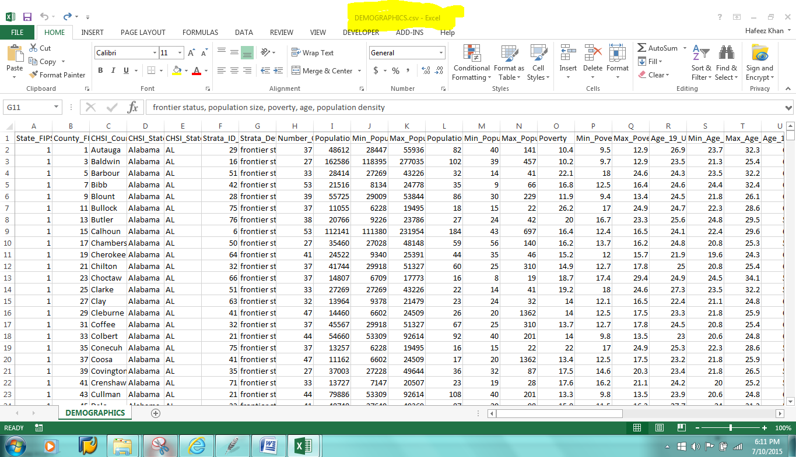

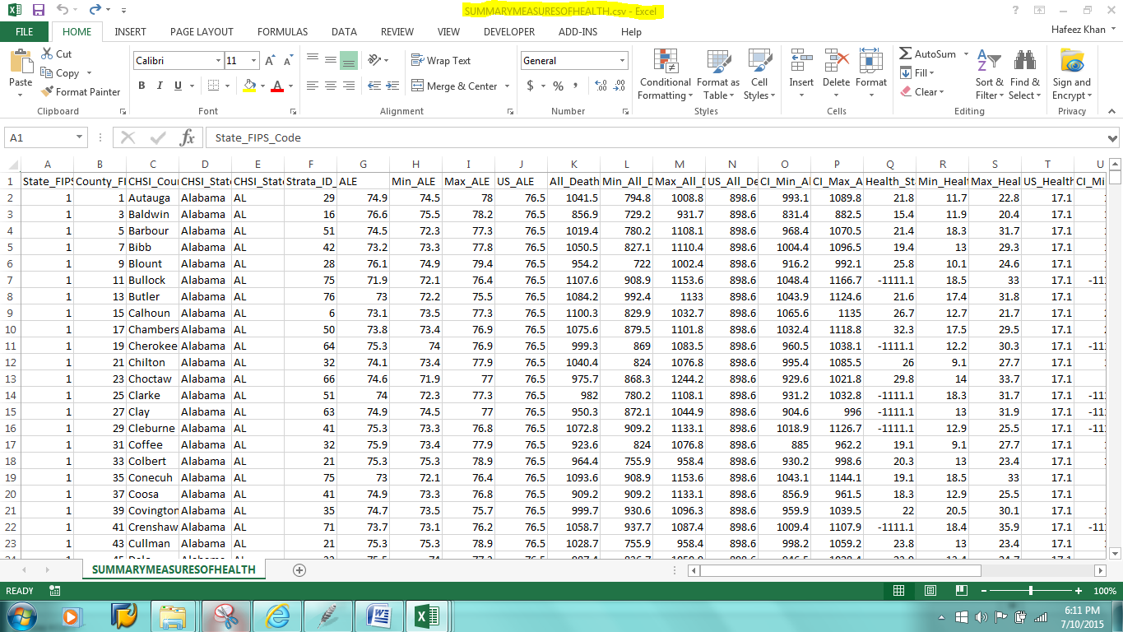

1. Made an empty file named Analytics.csv to get analytical combined the data from both files

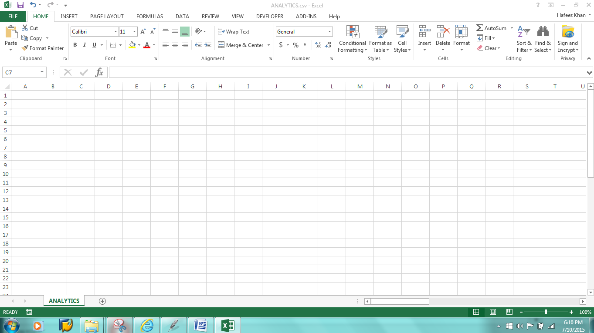

1. Wrote a python code to combine and add both files data to Analytics.csv file. You can notice that in Demographics.csv file, In Analytics.csv file “State_FIPS_Code” is combined to “County_FIPS_Code “ column to show the total result state wise.

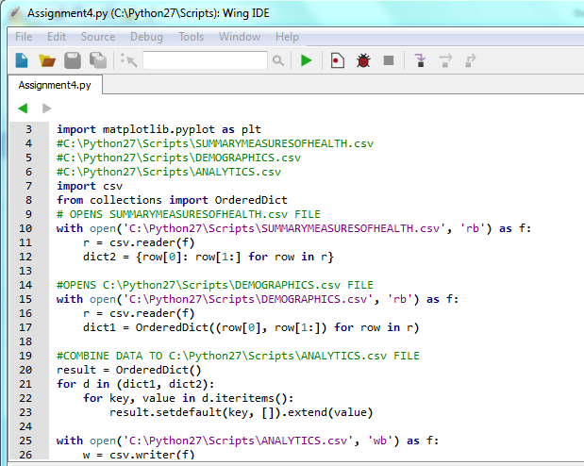

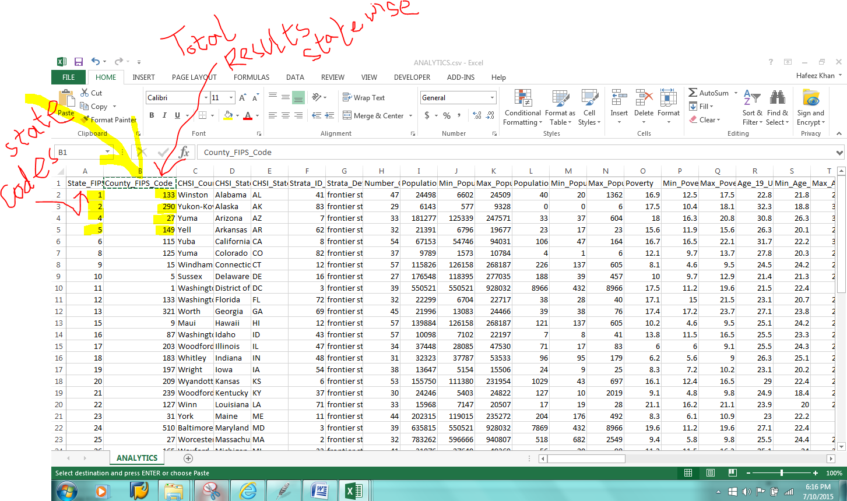

1. Wrote python code to graph Population size and poverty level state wise.

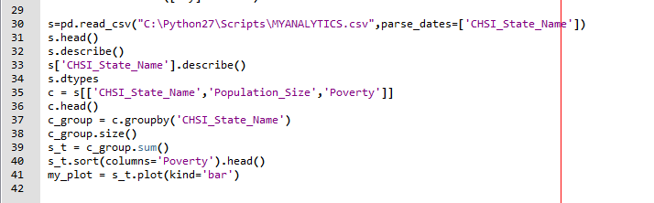

1. Graph to show two DCAT csv files data on a bar graph